Finance Electronic Files Management Guidance
April 2022

This document provides guidelines intended to assist Incident Management Teams in building a complete electronic Incident Finance Package (IFP) using FireNet for subsequent transfer to host agency/agencies. It provides a basis for consistent management of electronic finance files between teams, incidents, and agencies in all geographic areas; however, in some situations with added complexities such as managing multiple incidents under unified command or specialized record-keeping requirements, teams may seek and/or receive additional guidance from the host agency administrator(s) and/or assigned INBA(s).

Using these naming conventions consistently will build an IFP in the 08_Final_Finance_eDoc_Box folder and its subfolders in the Finance Channel that can be transferred to an external drive and uploaded to an agency system of record efficiently. The intent of limiting both the type and number of characters in file names as well the number of levels of folders is to ensure that the pathname to any file in the electronic IFP does not exceed 255 characters that can be managed by mass file transfer tools.

File and folder parameters:
- File/folder names do not exceed 30 characters in the IFP.
- File/folder names in the IFP include only alphanumeric characters, hyphens, and underscores.
- File extensions (e.g., .pdf, .docx, etc.) are not counted in the 30 characters.
- Dates are displayed as YYMMDD, using a leading 2-digit year.
- Resource order numbers include dashes only for subordinates.
- Resource order numbers for subordinates use a dash instead of period (e.g., E2-3)
- The creation of additional subfolders is restricted to no more than five levels in any unit.

Abbreviations are necessary. Common abbreviations are summarized in the tables below and on page 2.

Agreement (AGMT) Types
COMM |  | Commercial Agreement | LUA | Land Use Agreement
COOP |  | Cooperative Agreement | NCCxxx | National T2IA Crew (xxx is crew #)
EERA |  | Emergency Equipment Rental Agmt | T2Cxx | National T2 Crew (xx is crew #)
IBPA |  | Incident Blanket Purchase Agmt | VIPR | Virtual Incident Procurement Agmt
Employment Types
DOIAD |  | AD hired by DOI Agency | OTH |  | Other (type not listed)
FSAD |  | AD hired by USFS Unit | State (use 2-letter ID) |  | State Employee (e.g., GA, MN)
FED |  | Regular Federal Employee
Claim Types
EMP | Employee Claim |  | NTORT |  | Non-Tort Claim
GOVT | Government Claim (Not OF-289) |  | TORT |  | Tort Claim
GPD | Government Property Damage (OF-289) |  | Potential |  | Potential Claim

Document Types and Descriptive Information Needed
Document Type | File Name = Doc Type Plus | Example
Agreement (AGMT) | Request# | AGMT_E2
Casual Hire Form (CH) | LastName_Request# | CH_Doe_E2-3 (Example is a subordinate E#)
Amended Casual Hire Form (CHA) | LastName_Request# | CHA_Doe_E2-3
Check In Sheet (CIS) | Request# | CIS_E1
Commercial Invoice (COMINV) | Request# | COMINV_S3
Contract Claim (CC) | Description_Request# | CC_DoorDamage_E1
Contract Claim Documentation (CCD) | Description_Request# | CCD_FallerStatement_E5
Crew Manifest (CM) | Request# | CM_E1
Crew Time Report (CTR) | Request#_Date (or date range) | CTR_A1_YYMMDD (or YYMMDD-MMDD)
Combined CTR/Shift Ticket (CTR-ST) | Request#_Date (or date range) | CTR-ST_E1_YYMMDD (or YYMMDD-MMDD)
Evaluation (EVAL) | Vendor Name & Request# | EVAL_ABCContracting_E1
Fuel & Oil Issues (FUEL) | Request#_Date | FUEL_E6_YYMMDD
General Message (GM) | Subject_Request#_Date | GM_LodgingRequest_C5_YYMMDD
Miscellaneous (MISC) | Description_Reqest# | MISC_EngineInventory_E2
Interim or Final Invoice (286I/286F) | Request#_LastDate | 286I_E6_YYMMDD or 286F_E6_YYMMDD
Interim or Final Timesheet (288I/288F) | LastName_Request#_LastDate | 288I_Doe_O1 or 288F_Doe_O1
Interim/Final Pymt Pkg (PKGI/PKGF) | Request#_LastDate | PKGF_E1_YYMMDD or PKGI_E1_YYMMDD
Pre-Use Inspection (PRE) | Request# | PRE_E1
Release Inspection (POST) | Request# | POST_E1
Resource Order (RO) | Request # | RO_E1
Shift Ticket (ST) | Request#_Date (or date range) | ST_E1_YYMMDD (or YYMMDD-MMDD)
Motor Vehicle Accident (SF91) | ClaimsLog# | SF91_CL1
Witness Statement (SF94) | WitnessLastName_ClaimsLog# | SF94_Miller_CL1
Supporting Document – Payment (XD) | Description_Request# | XD_PartsReceipt_E6
Supporting Document Claims (XDC) | Description_ClaimsLog# | XDC_Photo_CL2
Property Loss/Damage (OF289) | ClaimsLog# | OF289_CL2
Claim - Damage/Injury/Death (SF95) | ClaimsLog# | SF95_CL3
USDA Employee Claim (AD382) | Claims Log # | AD382_CL4
DOI Employee Claim (DI570) | Claims Log # | DI570 _CL5
Cost Share (CS) | Date_Description | YYMMDD_CS_IAPSigned
Buying Team Spreadsheet (BUYT_SS) | Date | YYMMDD_BUYT_SS
Helibase Summary HBSum | Date & HB name if multiples used | YYMMDD_HBSum
Tankerbase Summary TBSum | Date & TB name if multiples used | YYMMDD_AbileneTBSum
Individual Aircraft Summary or 122 | Date & Tail# | YYMMDD_14HXSum

Finance Channel General Folders

5_Information: This is intended as a repository for information relative to managing the section. The contents do not follow a standard convention other than the listed parameters.

6_ICS213_GMs: Contents include general messages filed using the convention GM_YYMMDD_XXX, where xxx is a reference to the topic. File name limit is 30 characters.

7_ICS214_Unit_Logs: Contents include unit logs filed using the convention 214_YYMMDD_LastName.

LAND USE AGREEMENTS

Each Land Use Agreement (LUA) has an individual folder in the Finance Channel working files under 01_Land_Use_Agreements. Folders are named using the following convention:
4-digitRO_VendorName_RO_LUA. The 4-digit RO # is dropped in the Final Finance eDoc box.
Examples: S0001_DoeJ_S1_LUA (individual listed as owner; use last name and first initial)
S0002_BarkerRanch_S2_LUA (entity listed as owner)
An example of a completed LUA that has been moved to the Final Finance eDoc Box is shown:

Finance Channel > 8_Final_Finance_eDoc_Box > 1_Land_Use_Agreements > BarkerRanch_S2_LUA
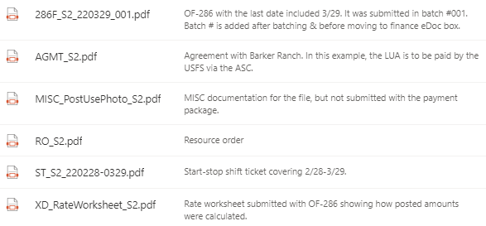

PROCUREMENT UNIT

A folder is established for each resource other than LUAs that is paid via OF-286 in the subfolder of “01_Invoice_Records” that corresponds to its Request #. Options are Crews, Equipment, Overhead or Supplies (C-#, E-#, O-# and S-# requests, respectively). Folders for resources paid via cooperative agreement also belong in these folders. Folders for resources under commercial agreement (i.e., “white envelope” resources) are maintained by the Cost Unit in the “02_Cost_Management” folder.

Folders are named using the format 4-DigitRO_VendorOrCooperatorName_RO_AgreementType*.
If the folder includes resources paid via OF-288, include employment type(s)*. *See page 1.
Examples: S0300_ForestryContracting_S300_EERA
E0002_OKForestrySvcs_E2_COOP_OK_DOIAD (crew is a mix of OK state and DOIAD)
When establishing a folder for a contract crew, the crew number is included in the agreement type:
Example: C0005_ForestryContracting_C5_NCC123

The leading 4-digit request number is used only in the working files and is removed when files are transferred to the Final Finance eDoc Box, leaving the files filed alphabetically by vendor or cooperator name. Ensure the folder name is limited to 30 characters in the Final Finance eDoc box.

If there is a need to separate documents within these parent folders, establish subfolders. Keep all documentation for a single request number (e.g., E2) and its subordinates (e.g., E2-1, E2-2, E2-3) within the parent folder and one additional level of subfolders.

The pathname under Finance Channel > 8_Final_Finance_eDoc_Box and folder contents for C-5, a contract crew that filed a contract claim:

Procurement_Unit > Invoice_Records > Equipment > ForestryContracting_C5_NCC123:

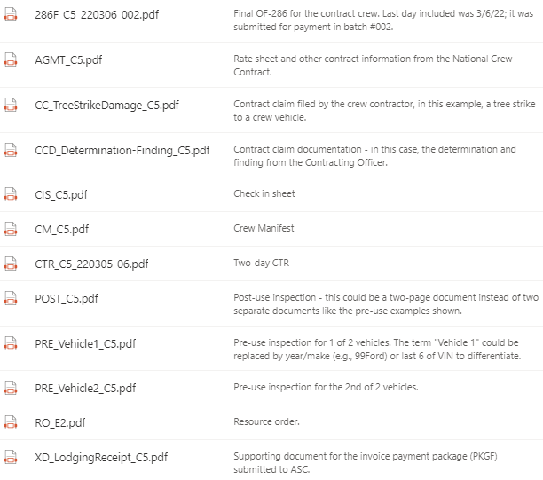

The pathname under Finance Channel > 8_Final_Finance_eDoc_Box and folder contents for E-2, a state engine with one AD crewmember:

Procurement_Unit > Invoice_Records > Equipment > OKForestrySvcs_E2_COOP_OK_DOIAD

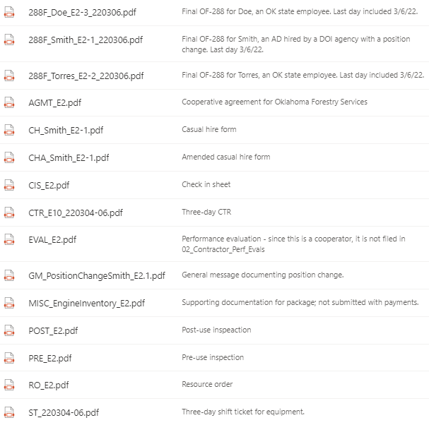

TIME UNIT

A folder is established for each resource that is paid via OF-288 unless that resource is included in the Procurement Unit files as a subordinate on a resource paid via OF-286. Folders are established in the subfolder of “01_Personnel_Time_Records” corresponding to the RO. Options are Aircraft, Crews, Equipment or Overhead (A-#, C-#, E-# and O-# requests, respectively).

Folders for single-resource overhead are named identically in the working files and in the Final Finance eDoc Box using this format: LastNameFirstInitial_RO#_Employment Type. The Finance Channel pathname and folder contents for O-1, J Doe, a federal employee, is shown below:

8_Final_Finance_eDoc_Box > Time_Unit > Personnel_Time_Records > Overhead > DoeJ_O2_FED
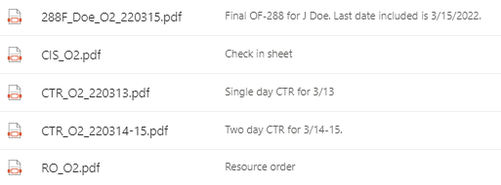

Working Folders for resources other than single-resource overhead are named using this format:
4-Digit RO#_Name_RO#_Employment Type(s). When moved to the Final Finance e-Doc Box, the leading 4-digit RO# is removed.
Examples: A0001_PineyHelitack_A1_FED
E0010_KYDBFE6161_E10_FED_FSAD (mixed employment types)

If there is a need to separate documents within these parent folders, establish subfolders. Keep all documentation for a single request number (e.g., E-10) and its subordinates (e.g., E10-1, E10-2, E10-3) within the parent folder and one additional level of subfolders.

The pathname in Finance Channel > 8_Final_Finance_eDoc_Box and folder contents for A1, a federal helitack crew:

Time_Unit > Personnel_Time_Records > Aircraft > PineyHelitack_A1_FED

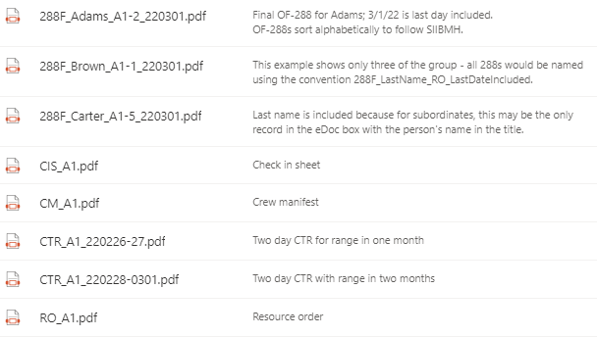

The pathname in Finance Channel > 8_Final_Finance_eDoc_Box and folder contents for E10, a federal Type 6 engine that did a crew swap after 3 days, demobed on day 6, and had 1 AD crewmember on each crew:

Time Unit > Personnel_Time_Records > Equipment > KYDBFE6161_E10_FED_FSAD

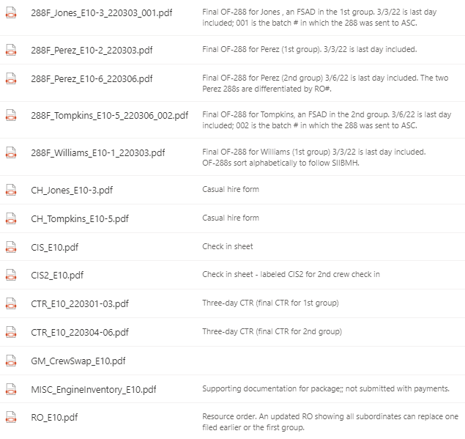

COMP/CLAIMS UNIT

Compensation for Injury files include the ICS-226 Incident Injury/Illness Log or equivalent document, which is a single document used through the life of the incident regardless of the number of IMTs assigned. These files may also include generic statistics summarizing unit activity and relevant information on unit management. The contents cannot include Privacy Act protected information. An example of the working file pathname with contents is shown below:

Finance Channel > 1_COMP > 01_Comp_for_Injury
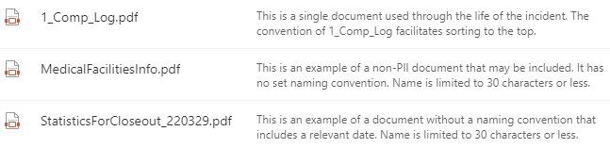

Claims files include the ICS-227 Claims Log or equivalent document, which is a single document used through the life of the incident regardless of the number of IMTs assigned. Claims subfolders are created using the convention Claim#_Claimant/PotentialClaimantName_Subject_ClaimType. Contract claims are an exception – those are filed in the associated contractor folder in the Procurement Unit.
Examples from working files are included below. See also page 1 for a list of claim types.

Finance Channel > 1_COMP > 02_ Claims

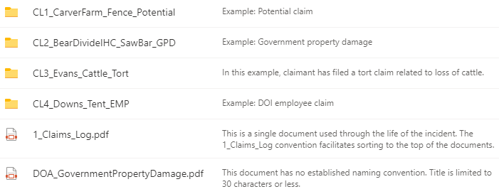

Claims > CL1_CarverFarm_Fence_Potential

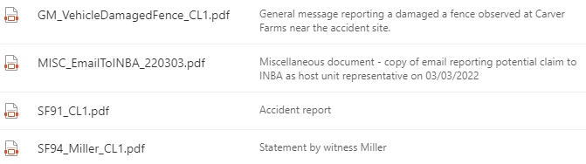

Claims > CL2_BearDivideIHC_SawBar_GPD

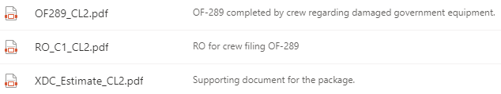

Claims > CL3_Evans_Cattle_Tort

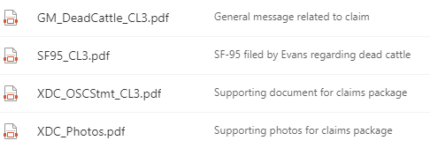

Claims > CL4_Downs_Tent_EMP

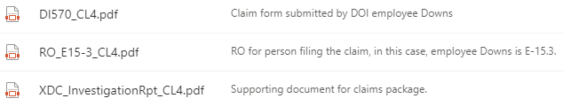

COST Unit

01_Aircraft_Costs: There are three types of folders for aircraft records. For Helibase and Tankerbase summaries, use the corresponding folder. If there are additional aircraft reported individually, establish folders using the convention AircraftTail#_RO#. Examples from working files are shown; however, the name and contents are identical in the Final Finance eDoc Box.

Finance Channel > 2_COST > 01_Aircraft_Costs > 14HX_A1
(Note: As the first individual aircraft folder, this was “created” by renaming the Aircraft#_Tail# folder)

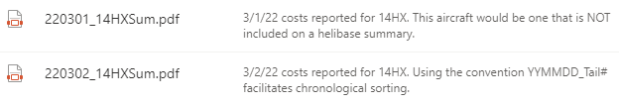

Finance Channel > 2_COST > 01_Aircraft_Costs > Tankerbase
(Note: Manage helibase files similarly to tankerbase files shown below)

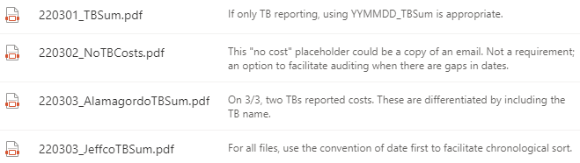

02_Cost_Management – The COST documents processes/methodologies developed and/or used to calculate and track costs such as travel in/out, per diem, and cache. This documentation is filed under the main folder. Caterer, shower, buying team and lend/lease subfolders are provided; establish additional folders as needed to track other costs, including any “white envelope” resources tracked separately by the COST. Examples from the working files are shown; however, the Final Finance eDoc Box will be the same.

Examples:
Finance Channel > 2_COST > 02_Cost_Management
Finance Channel > 2_COST > 02_Cost_Management > 01_Caterer
(Note: The “02_Shower” folder would be handled in the same way)
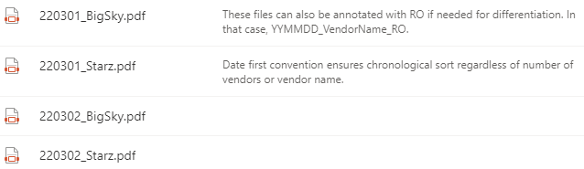

Finance Channel > 2_COST > 02_Cost_Management > 03_BUYT_Spreadsheet
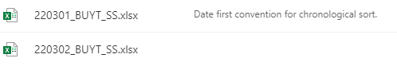

Finance Channel > 2_COST > 02_Cost_Management > 04_Lend_Lease
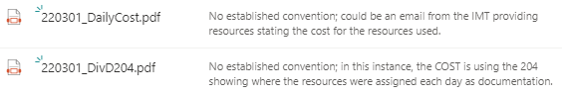

Finance Channel > 2_COST > 02_Cost_Management > Evergreen_S1_COMM
(Note: This is an example of a “white envelope” resource the COST is tracking)
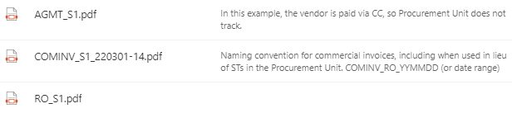

Finance Channel > 2_COST > 02_Cost_Management > Tracking_Spreadsheets
(Note: This is an example of a folder created by the COST to organize records)
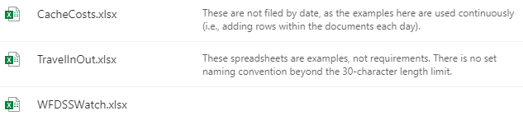
03_Daily_Cost_Tracking – This folder contains EIS reports generated for CTD and other agency-required reporting. Subfolders are provided for Current Day Summary and Group Category Summary; however, additional subfolders may be created at this level as needed.

Finance Channel > 2_COST > 03_CostManagement > Current_Day_Summary
(Note: The Group_Category_Summary folder would be handled in the same way)

Finance Channel > 2_COST > 04_Cost_Share
(Note: If the agreement is amended later, the effective date at the start of file name will differentiate it. If there are multiple agreements in place, subfolders may be created to separate records.)

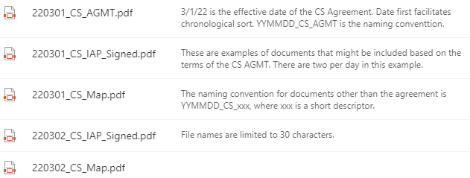

Finance Channel > 2_COST > 05_Final_Cost_Statement_IHF – Self-explanatory.

